

Sales
and
Marketing
Automation
for
Multi-tier
Distribution,
Dealer
and
OEM
Sales
Channels

SALES CHANNEL AUTOMATION SYSTEM
INDIRECT CHANNEL SALES CHALLENGES

Global Sales, Global Challenges

Effective marketing to influencers and decision-makers is the key to closing sales. Yet, if you sell through indirect sales channels, gaining access to all the participants in the sales process has been very difficult. Distribution partners, whether dealers, distributors, even OEM partners, are independent organizations, only loosely associated through contracts and business agreements, with whom it can be difficult to exchange sensitive information. Yet, to optimize sales through those trading partners you must be able to exchange a large amount of sales and marketing information.

Global Impact

In the past, sales and marketing information has been exchanged as paper catalogs, purchase orders, invoices, etc. This hard-copy information is not only expensive to generate, but also expensive and time-consuming to keep up to date. Adding to the cost of producing this information a company’s primary language is the cost of generating the information in the many other languages, cultures and currencies in which your company does business. The flood of paper that results is difficult to distribute, analyze, manage, warehouse and finally dispose.

Global Sources

Keeping sales and marketing information up to date is all the more challenging given the multiple sources, internal and external, for the required information. Product, sales and marketing information may come from back office automation systems such as MRP, ERP, Order Fulfillment, and Vendor Manage Inventory systems, engineering systems such as Product Data Management and Product Data Publishing systems and from upstream suppliers’ sales and marketing systems. All hard-copy and most electronic commerce systems require re-keying of this information for distribution.

Global Security

Delivering sales and marketing information over the Internet can succeed only if there is sufficient security control over the applications and information your trading partners can access. In this new age of Extranet access by third-party trading partners and collaborative supplier engineers, simple gateway and system security is necessary but not sufficient. To provide proper control over proprietary Intranet-based information you must also be able to control access to individual applications, individual records within application databases, and even individual fields within those records.
Global Distribution

Your sales and marketing information must be delivered to and through your entire distribution network. Multi-tiered distributors, dealer networks and OEM customer supply chains increase the challenge of getting the right information to the appropriate trading partners. Doing so with appropriate controls over who is allowed to see what information throughout the entire multi-tiered network is extremely challenging. Yet distributing sales, marketing and product information throughout your entire distribution network and supply chain is critical to your ability to make rapid and accurate business decisions.

The challenges and expense associated with managing sales and marketing information has traditionally limited the amount and value of information exchanged with your distribution partners. The advent of Extranet technologies enables cost-effective, secure delivery of sales and marketing information to Extranet-based trading partners.

WEBENABLE SALES CHANNEL AUTOMATION SOLUTIONS

Enterprise Relationship Management for your Distribution Network

WebEnable brings the power of sales automation to manufacturers who sell through multi-tiered dealerships, distribution networks and OEM supply chains. The WebEnable Sales Channel Automation System includes applications for product management, marketing campaign management, dealer management, account management, order management, contact management, opportunity management, training management and problem management – all designed to meet the specific needs of indirect channel sales.

WebEnable’s Sales Channel Automation System allows marketing managers to make use of a wide range of targeted encyclopedias to share multinational and multilingual product, sales and marketing information based on a single common product or service database. It has the capacity to handle tens of thousands of products, each with sophisticated collateral information, while at the same time tailoring the restricted access of each trading partner within each encyclopedia. Through these encyclopedias you can empower the many internal and external participants in your indirect sales process by supporting their many unique role-specific requirements for managing and analyzing sales, marketing and product information.
Fulfillment Managers distribute collateral for thousands of products to thousands of distributors across multiple channel partner programs through multiple distribution tiers. In the past, the high cost of printing, warehousing and distributing paper and CD-ROM collateral made one-to-one marketing impossible.

Product Managers produce the often proprietary specifications and collateral for thousands of products for use by multiple channel partner programs. They strain to hear the “voice of the customer” through multi-tier distribution networks - critical in this age of “design to order” sales and collaborative supply chain engineering .

Your Channel Managers manage the distribution of leads, requests for proposal (RFP) and requests for quote (RFQ) down through the multi-tier distribution network. In return, channel managers attempt to collect sales and account information from the channels to improve both product and marketing delivered to the customers.

Account Managers for your distributors need to collaborate on team selling across the distribution network. In addition they need to be able to manage account information, outstanding orders, sales, leads, RFPs, RFQs and bids. They need to be able to get the latest product information to effectively propose solutions to their customers.

Logistics Managers for your OEM customers deliver the ongoing volume replenishment sales that make the initial sales effort profitable. They must be able to develop purchase plans and forecasts, submit and track replenishment orders, and manage sales contracts, subscriptions, upgrades, warrantees and service plans.

Specifying Engineers must have access to the latest product technical specifications. Often the most important sale is to the specifying engineer who designs your part into their new product. If the specifying engineer doesn’t specify your product you may never get the opportunity for volume replenishment sales. To enable “specifying engineer” procurement, we must enable parts sourcing and collaborative engineering through channel sales systems.



For Purchasing Managers used to negotiating lowest unit-cost. the opportunity to reduce the lifecycle cost of a contract can increase sales and improve margins.
An entire commercial world without borders is at hand, free from the obstacles of oceans, national borders and regulatory disharmony. WebEnable’s Sales Channel Automation System enables business to be conducted without regard to differences in time zones, languages and currencies. WebEnable facilitates the evolution of global indirect marketplaces - making it easier, quicker and cheaper for a company to do business within and beyond its national borders through its existing multi-tier distribution network.

Marketing Managers struggle to catch the “ear of the customer” through multiple channel tiers, frustrating the delivery of effective cooperative marketing programs.

WEBENABLE SALES CHANNEL

The WebEnable Sales Channel Automation System has been developed to meet the needs of international corporations distributing products through Indirect Sales Channels. It supports the ability to share marketing, sales account and trading partner information in multiple languages, to multiple countries with country-specific duties, taxes and currencies.

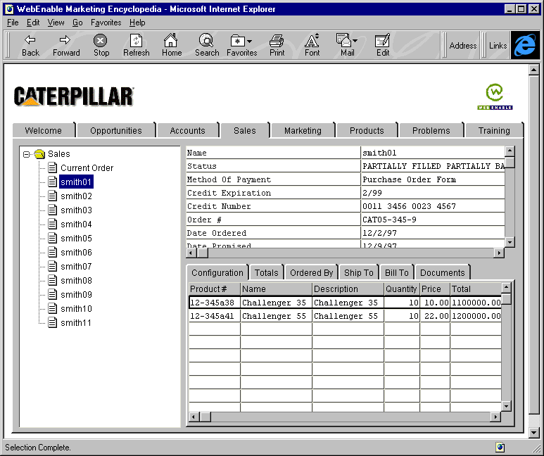

WebEnable Sales Management
The WebEnable Sales Channel Automation System includes support for generating and managing orders. This dramatically reduces mis-orders and mis-ships. WebEnable Sales Management supports the ability to share purchase order information with sales and marketing partners. Trading partners can track order status and perform sales trend analysis over the Internet with the assurance that partners are only able to access order information specific to their relationship with the supplier. Orders may be distributed to an order administrator as either text SMTP mail messages or EDI transaction sets.

WebEnable Opportunity Management
The WebEnable Opportunity Management supports distribution, tracking and management of opportunity information between partners in a distribution network. Manufacturers may automatically assign leads generated from cooperative marketing campaigns to specific channel partners and track their distribution and handling down through the distribution network. Both manufacturer marketing and channel sales partners can evaluate the return on investment for leads, RFPs, RFQs and bids based on orders received and revenue generated. Channel sales partners can manage leads, RFPs, RFQs, bids, standing orders, recurring orders, outstanding orders and purchase plans

WebEnable Product Encyclopedia
WebEnable Sales Channel Automation System Product Encyclopedia allows marketing managers to deliver information on a large number of products with sophisticated collateral information. Multiple concurrent product encyclopedias may be defined for specific industries, partners, seasons, product lines, etc. based on a single common product database.

Marketing managers determine who can see what information in any and all encyclopedias. This allows marketing managers to use the Product Encyclopedia to share proprietary product information with internal users while limiting access by channel partners. These security features ensure that channel partners are able to access information appropriate to their relationship with the supplier (e.g. per partner price plans, discount schedules, exclusive product offerings, etc.).

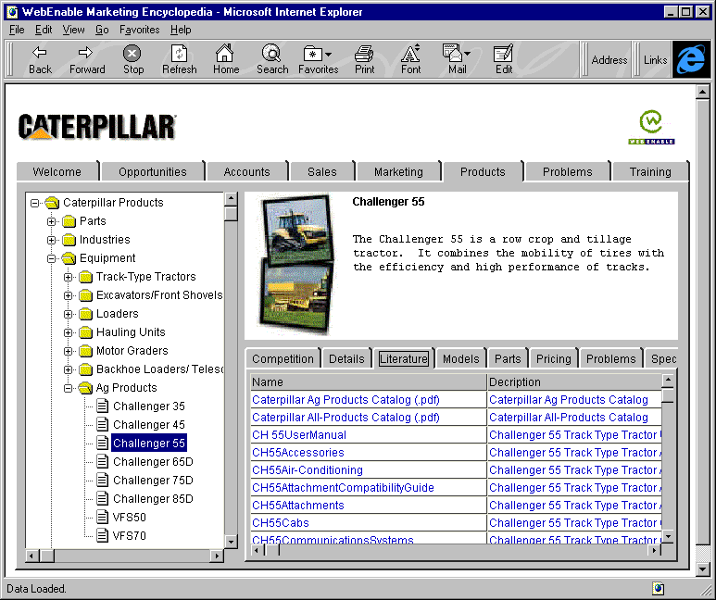

WebEnable Account Management
The WebEnable Account Management supports the ability to manage and distribute contact and account information including: corporate information, purchase history, problem history, RFP/RFQ history, bid history, order history, purchase plans, standing/recurring orders, marketing history, inquiry history, suggestion/requirements history, training history, billing information, contact management and calendar management.

WebEnable Marketing Management
The WebEnable Marketing Management supports distribution and management of cooperative marketing campaign and program information between partners in a distribution network. Manufacturers may automatically assign leads generated from cooperative marketing campaigns to channel partners that participated in their funding. Both manufacturer and channel sales partners can evaluate the return on investment for marketing campaigns and programs based on leads, orders and revenue generated.

WebEnable Training Management
The WebEnable Training Management supports the ability to distribute product, process and policy training material. Training management allows channel managers to organize course information including content, texts, assignments, tests and reference material. Training courses may be associated with specific products, problems, maintenance procedures, sales processes and corporate policies.

WebEnable Problem Management
The WebEnable Problem Management supports distribution and management of customer and product problem information between partners in a distribution network. Problems may be associated with related problems, training, maintenance procedures and technical specifications. Product managers can track problem history across all affected products and service history associated with individual problem reports.

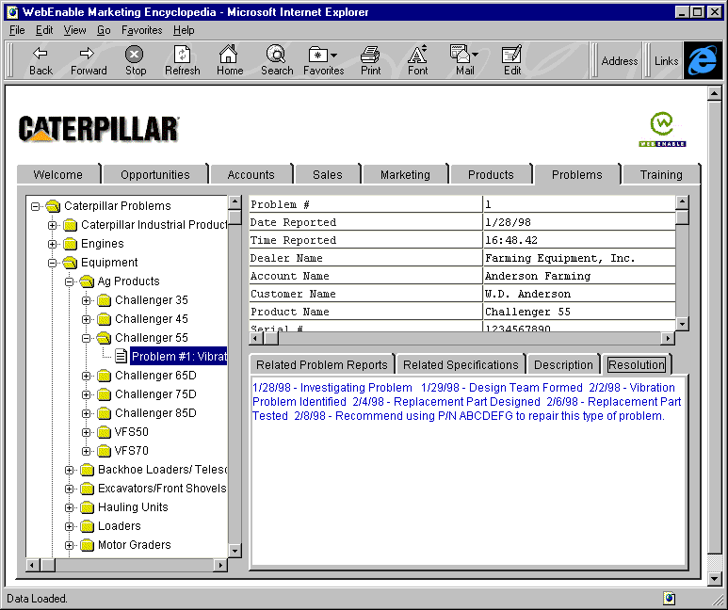
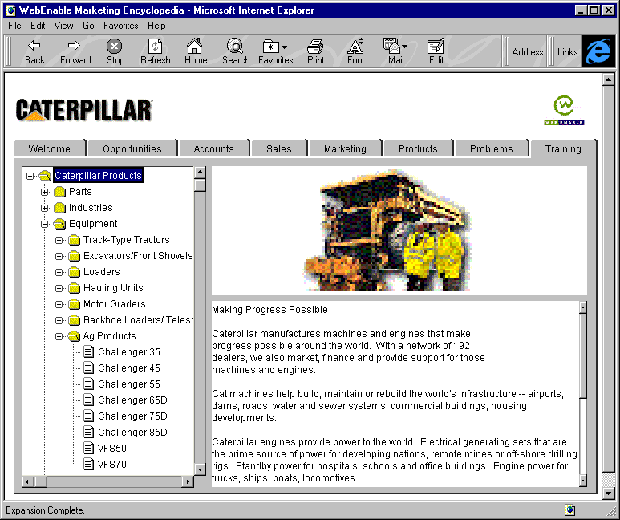
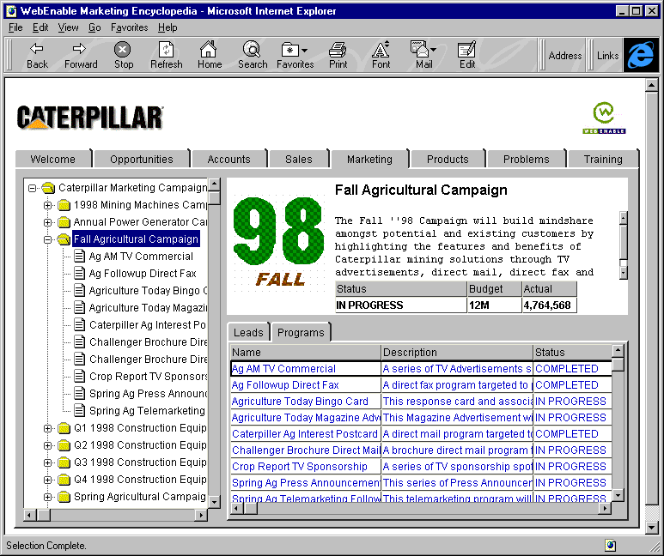
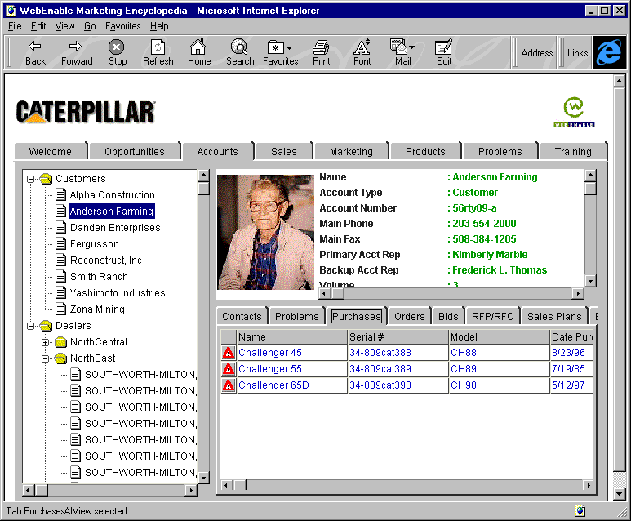
AUTOMATION APPLICATIONS

WebEnable Sales Channel Automation ensures that trading partners are able to access information specific to the products they distribute and their relationship with the supplier.

WEBENABLE SALES CHANNEL AUTOMATION BENEFITS

Power of Sales Automation for Multi-tier Distribution Networks

WebEnable’s products allow the manufacturing companies to realize the tremendous efficiencies of electronic commerce - optimizing the indirect sales channels peopled by OEM customers, dealers, distributors, wholesalers, value-added resellers and systems integrators. WebEnable’s unique Extranet applications permit manufacturers to manage the sales process across their entire indirect distribution network. The WebEnable Sales Channel Automation System increases manufacturers’ revenue and profitability through:

Improved Targeting. WebEnable’s Sales Channel Automation System allows marketing managers to make use of a wide range of targeted sales encyclopedias to share multinational and multilingual product, sales and marketing information based on a single common product or service database. By ensuring that only information appropriate for an industry, company or individual is visible and accessible, you can safely share information specific to your relationships with distributors and suppliers.

Improved Effectiveness. By personalizing product information to individual customers, dealers and trading partners, the Sales Channel Automation System enables true one-to-one marketing. A company can easily construct gradations of access to different constituents, ranging from solely public data for a prospect, to the discount schedule for a specific trading partner, to the most sensitive proprietary information for its own executives.
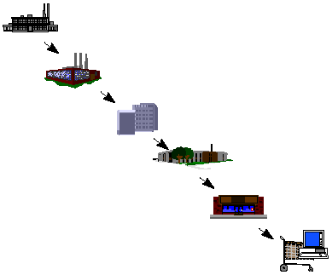

Improved Efficiency. WebEnable provides a complete, real-time system to manage, track and evaluate the performance of the whole distribution network. Information flow is complete between manufacturers, dealers, partners and everyone else in the channel. For the first time, manufacturers can see at a glance the status of each prospect in the sales process, the performance of each incentive program and the volume of each trading partner.

Increased Security. WebEnable’s Sales Channel Automation System allows trading partners controlled secure access to otherwise proprietary information. WebEnable enables corporations to tailor the information access permitted each of its trading partners while maintaining security over all of its proprietary data.

Improved Timeliness. When sales and marketing information is disseminated using traditional methods it is often obsolete by the time it is received. WebEnable products ensure that up-to-the-minute information is accessible throughout the entire distribution network.

Lower Cost. The overall expense of printing and distributing paper-based catalogs are extraordinary. Even CD-ROMs are costly to publish and distribute. WebEnable’s products decrease these expenses dramatically.
WEBENABLE TESTIMONIALS

“The industry need for WebEnable’s Sales Channel Automation products and your knowledge of the industry’s need are clearly articulated in the architecture. WebEnable’s attention to these requirements and competence in delivering a solution has resulted in an exceptional channel automation product.”

John Sheridan, COO and Executive Director, InfoTest/National Center for Manufacturing Sciences

“We needed a far more sophisticated approach for managing customer and dealer information. Your product was selected to fill this role early on because it met our initial requirements. As the project evolved and our requirements were finalized, WebEnable rose to the occasion and worked to adapt your product to meet the needs of the project.”

Dr. William Estrem, D.H. Brown Associates, EPR Project Manager

“I have become more convinced as time rolls on that the Internet and all of its variations will be the way to go. As you know, the electronic distribution and OEM business has all the elements needed to be a perfect candidate for WebEnable. The need is currently being reviewed at all levels of the industry.”

Don Lupfer, Electronic Components Distribution Consultant

“Attempting to implement a global market-based information strategy via client-server, was too expensive and would have taken over 12 months. A web-based strategy could be implemented in 3 months at dramatically lower cost…. anybody can use a browser.”

VP Sales and Marketing, Major Electrical Component Manufacturer

“Every time we turned the EPR server on, WebEnable worked. I sure can’t say that about all the project components, including some from large, well established companies. But WebEnable worked 100% and we are really impressed.”

Technical Evaluators, Major Heavy Equipment Manufacturer



World Headquarters
WebEnable, Inc.
110 Tahanto Trail
Harvard MA 01451
v: 978.456.6903
f: 978.456.6904
u: www.webenable.com
e: enable@webenable.com

