Report
Strategy



Wireless Operators US 2000
Consulting Report

Executive Summary: This report provides a survey of North American Wireless Network Operators, with a focus on operators in the United States. The U.S. wireless voice and wireless data markets are highly fragmented due to adopted of multiple competing wireless air interface standards and data transmission technnologies. In addition, no one operator has succeeded yet in delivering true coast-to-coast services across all states and territories. Operators have been content to cover major metropolitan centers with their associated high density market population. This has resulted in difficulty roaming nationwide. This report lays the foundation for selecting service providers through which to deploy wireless medical, educational, entertainment and business applications by providing the critical information required for making the selection.

Purpose: This report provides a survey of North American Wireless Network Operators to determine which are suitable for wireless delivery of medical, educational and business information and associated application functionality. It is one of a family of reports on wireless technology that include:

- Wireless Devices
- Wireless Application Protocols
- Wireless Application Service Providers
- Wireless Application Development Tools
- Recommendations for Developers of Wireless Applications

Taken together these reports provide an overview of the set of technologies required to deliver wireless data and application services and products. The final recommendations report provides guidance on the selection of the appropriate technologies and makes a limited number of recommendations for specific solutions.

Problem: Companies that wish to develop and deploy wireless data services or wireless applications face the challenges of delivering useful application functionality and business information through a device appropriate for mobile use over a wireless network that supports the device and associated application protocols. The current wireless data networking market is highly fragmented due to adopted of multiple competing wireless air interface standards and data transmission technologies. In addition, no one operator has succeeded yet in delivering true coast-to-coast services across all states and territories. Operators have been content to cover major metropolitan centers with their associated high density market population. This has resulted in difficulty roaming nationwide. This means that development of wireless applications and data services requires careful selection of:

- a specific model of device on which to deploy the application;
- which supports a specific application protocol;
- supported by a specific set of wireless service providers;
- who offer a specific set of development tools

Discussion: There are a wide variety of national, regional and even international operators that could potentially be used to deploy mobile or wireless applications. They range from small local operators that support a single city to multinational Global 2000 corporations that deliver wireless network services around the globe.

There are a few critical technical features that must be considered when selecting a wireless network operator through which to deploy wireless data services or wireless applications.

Coverage Area – What states and/or cities does the operator support?

Reseller for – Wireless Internet Service Providers (WISPs) often do not implement the physical wireless network, but rather resell network services from one of the national Wireless Network Operators.

Subsidiaries – Significant consolidation has occurred in the wireless markets over the past year. Many operators have either been acquired by or merged with another. The acquired companies often continue to operate as separately branded subsidiaries. It can be valuable in business negotiations to know the relationships between seemingly separate companies.

Affiliate of – In addition to M&A activity, many operators have formed affiliations with each other in an attempt to deliver coast-to-coast services.

Protocols Supported – How does the service provider communicate with the end-user’s wireless device.

Devices Offered – What devices are sold or explicitly supported by the cellular phone companies, paging companies or wireless data company.

Devices Supported – What devices are supported by the protocol used by the cellular phone companies, paging companies or wireless data company.

Subscription Plan – The cost of wireless subscription can determine whether the application is accepted by the target market. However useful the application, if the monthly or annual subscription cost is deemed to be too expensive, adoption of the application or service will be slow and may ultimately be rejected by the market. We have documented only standard monthly subscription rates as of October 2000. While operators often have special promotional rates and/or annual rates, we have focused on monthly rates to ease initial price comparisons. Since major applications or service providers will be likely to negotiate a business relationship at a wholesale level, these rates are for rough comparison.

Approach: For this report we have focused on major wireless network operators within the United States. These operators have the potential of providing coast-to-coast service over the coming years as they acquire or merge with smaller regional operators. We have documented many of the regional carriers in a separate section, but have not attempted to collect complete information on these smaller operators. We have provided information on the first few of a new type of “operator” – the Wireless Internet Service Provider (WISP). WISPs resell network connectivity from larger operators while providing value-added wireless data services.

Wireless Internet Service Providers

GoAmerica.com
Coverage Area: Nationwide
Reseller for: BellSouth (Mobitex), Metricom Ricochet, Motient Wireless and Motient Satellite Networks
Protocols Supported: CDPD, Mobitex, ReFLEX, Satelite, Ricochet
Devices Supported: Palm (w/appropriate add-on), Handspring (w/appropriate Springboard module), TRG Pro, Novatel modems, Sierra modems
Subscription Plans: Go.Lite: 9.95/month for first 25KB, additional traffic charged at 10¢ per kilobyte for CDPD network and 30¢ per kilobyte for BellSouth network; Go.Unlimited: $59.95/month unlimited traffic. Both plans charge an additional 10¢ per kilobyte for traffic generate by non-GoAmerica software products. Go.Ricochet: $74.95/month unlimited usage.

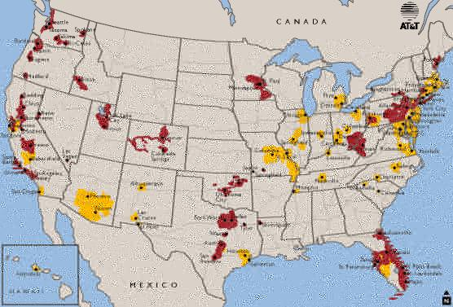
GoAmerica CDPD US Coverage (AT&T Wireless)

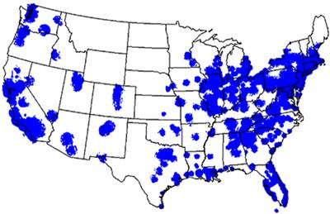
GoAmerica Mobitex US Coverage (BellSouth)

Omnisky
Coverage Area: Nationwide
Reseller for: AT&T Wireless CDPD
Protocols Supported: CDPD
Devices Supported: Palm (w/appropriate add-on), Handspring (w/appropriate Springboard module), TRG Pro, Novatel modems, Sierra modems
Subscription Plans: $39.95/month unlimited usage

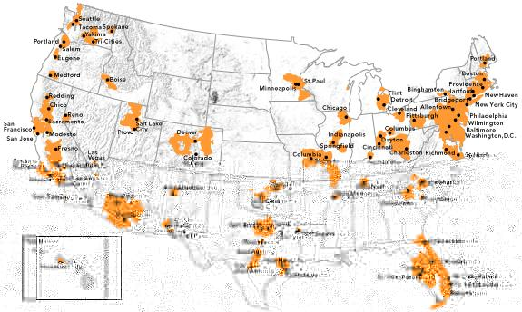

Palm.net
Coverage Area: Nationwide
Reseller for: BellSouth Wireless
Protocols Supported: Mobitex (Planned: CDPD, GPSR)
Devices Supported: Palm (w/appropriate add-on), Handspring (w/appropriate Springboard module), TRG Pro, Novatel modems, Sierra modems
Subscription Plans:
- Basic: 9.99/month for first 50KB, additional traffic charged at 20¢ per kilobyte
- Expanded: 24.99/month for first 150KB, additional traffic charged at 20¢ per kilobyte
- Volume: 39.99/month for first 300KB, additional traffic charged at 20¢ per kilobyte
- Unlimited: 44.99/month unlimited traffic
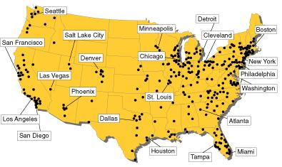

Yadayada.com
Coverage Area: Nationwide
Reseller for: Verizon
Protocols Supported: CDPD
Devices Supported: Palm (w/appropriate add-on), Handspring (w/appropriate Springboard module), TRG Pro, Novatel modems, Sierra modems (for Palm-based devices only)
Subscription Plans: $39.95 unlimited wireless Internet
Notes: Messaging Portal and Web Clipping WASP for Palm OS Devices includes WISP CDPD services. Yadayada expects to have final network coverage maps available by year end. They are using Verizon as a carrier and through Verizon’s carrier agreements should have access to the full US CDPD network.

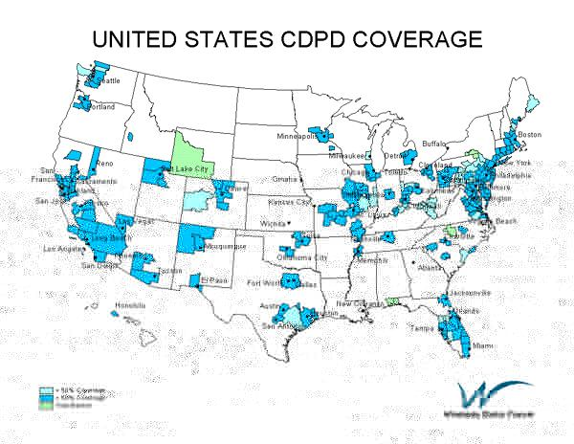

Major US Wireless Network Service Providers

AT&T Wireless
Coverage Area: Major US Cities including: Ariz.: Phoenix, Tucson; D.C.: Washington; Ga.: Atlanta; Ill.: Chicago; Mass.: Boston; Md.: Baltimore; Mich.: Detroit; Mo.: St. Louis; N.C.: Charlotte; Ohio: Akron, Canton, Cleveland, Columbus; Pa.: Philadelphia
Subsidiaries: NA but many affiliates
Protocols Supported: TDMA, CDPD
Devices Offered: Ericsson R280LX, Mitsubishi T250
Devices Supported: Ericsson, Mitsubishi, Motorola, Nokia, Palm (w/appropriate add-on), Handspring (w/appropriate Springboard module), TRG Pro, Novatel modems, Sierra modems
Subscription Plans: Basic: Free w/Select Voice Plans includes unlimited wireless Internet access; Plus: $6.99 includes Basic services plus e-mail, Word and Text attachments; Premium: $14.99 includes Premium services plus Calendar, ToDo and Contact management.

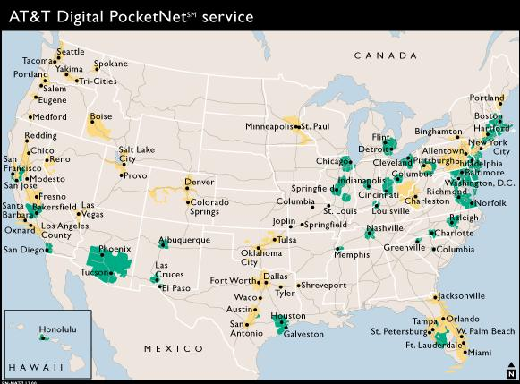

BellSouth Wireless
Coverage Area: Alabama, Arkansas, Florida, Georgia, Indiana, Kentucky, Louisiana, Mississippi, North Carolina, South Carolina, Tennessee, Texas, Virginia
Subsidiaries: Mobility (TDMA), Mobility DCS (GSM), CellularOne (TDMA?), Cingular (Mobitex)
Protocols Supported: CDPD, GPSR, TDMA, GSM
Devices Supported: Ericsson, Mitsubishi, Motorola, Nokia, Palm (w/appropriate add-on), Handspring (w/appropriate Springboard module), TRG Pro, Novatel modems, Sierra modems
Subscription Plans: Billed as “Data Minutes” against Digital PCS phone subscription plan

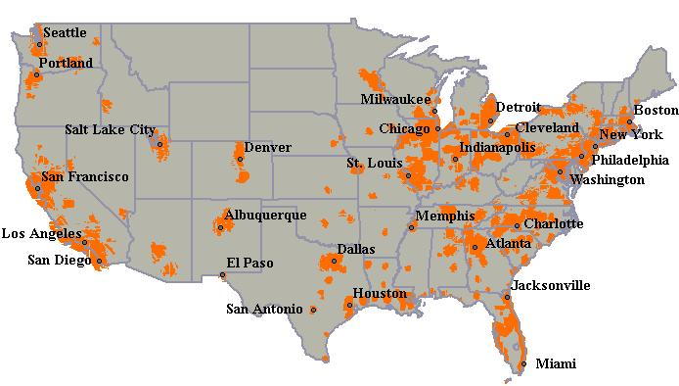
BellSouth US Mobitex Coverage

Nextel
Coverage Area: Nationwide
Subsidiaries: NA
Protocols Supported: iDEN
Devices Supported: Motorola i500plus, i550plus, i700plus, i1000plus, i2000
Subscription Plans: Online (basic): Free w/Voice Plans includes unlimited use of MSN Mobile, Shopping and Nextel Services and 300 text pages; Online Plus: $5.00/month includes basic features plus Web Browsing; Online Two-Way Messaging: $10.00/month includes Send, receive and reply to text messages (up to 500 characters); eDispatch: $40.00/month.

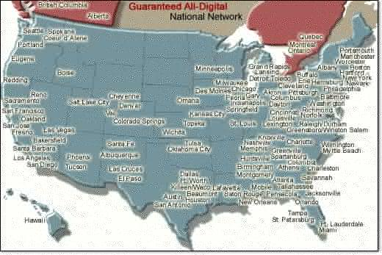
Nextel US Coverage

PageNet
Coverage Area: Nationwide
Protocols Supported: ReFLEX
Devices Supported: Motorola Timeport P935, P930, Pagewriter 2000X
Subscription Plans: $27.95/month pager messaging only

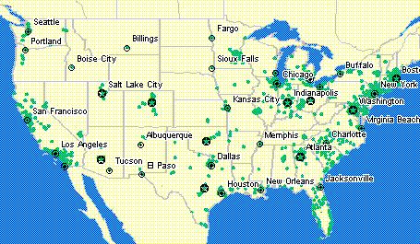

Pagenet US Coverage

Qwest
Coverage Area: Ariz.: Phoenix, Tucson; Colo.: Avon, Boulder, Breckenridge, Colorado ski areas, Colorado Springs, Denver, Fort Collins, Frisco, Georgetown, Greeley, Idaho Springs, Silverthorne; Idaho: Boise; Minn.: Minneapolis-St. Paul, Rochester, St. Cloud; Montana; Ore.: Portland, Salem; Utah; Wash.: Spokane, Vancouver
Subsidiaries: Qwest, USWest Wireless
Protocols Supported: CDPD, CDMA
Devices Supported: Ericsson, Kyocera, Mitsubishi, Motorola, Neopoint, Nokia, Qualcomm, Samsung, Sony
Subscription Plans: BrowseNow: $14.95/month; BrowseNow and Qwest.net: $29.90/month; MessagePak: $4.95/month; Information Services: $3.00/month for 3 topics, $5.00/month for 6 topics.

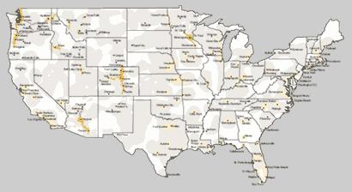

Qwest US Coverage

Ricochet
Coverage Area: Atlanta, Baltimore, Dallas/Ft Worth, Houston, Philadelphia, Phoenix, San Diego, San Francisco Bay Area, New York City (Manhattan), Washington DC (28.8 Kbps), Seattle (28.8 Kbps). Planned: Boston, Detroit, Chicago, St Louis, Minneapolis, Kansas City, Denver, Salt Lake City, Los Angeles
Protocols Supported: IP over proprietary datalink via External Modem
Devices Supported: Windows CE/ME/2000/NT, Apple MacIntosh
Resellers: GoAmerica, Juno Express, Wireless WebConnect,
Subscription Plans: $74.99 – $79.95/month

SBC Wireless
Coverage Area: Arizona, Arkansas, California, Colorado, Connecticut, Florida, Georgia, Illinois, Indiana, Kentucky, Louisiana, Maryland, Massachusetts, Michigan, Minnesota, Missouri, Nevada, New Hampshire, New Jersey, New York, North Carolina, Ohio, Oklahoma, Oregon, Pennsylvania, Puerto Rico, Rhode Island, Tennessee, Texas, Utah, Virginia, Washington DC, Washington, Wisconsin
Subsidiaries: Ameritech, Southwestern Bell, Pacific Bell (GSM), Nevada Bell, SNET, CellularOne/Cingular, SBC Telecom, Sterling Commerce, Prodigy Communications
Protocols Supported: CDPD, GPSR, CDMA, GSM
Devices Supported: Ericsson, Kyocera, Mitsubishi, Motorola, Neopoint, Nokia, Qualcomm, Samsung, Sony, Palm (w/appropriate add-on), Handspring (w/appropriate Springboard module), TRG Pro

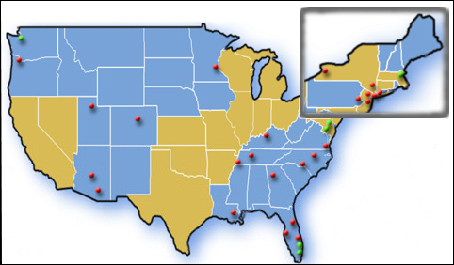

SBC Wireless US Coverage

Skytel
Coverage Area: Nationwide
Protocols Supported: ReFLEX
Devices Supported: Palm (w/appropriate add-on), Handspring (w/appropriate Springboard module), RIM Blackberry, Motorola Pagers, Glenayre Pagers
Subscription Plans: SkyWriter Plan: $24.95/month includes 10,000 characters, billed in 10-character increments per message, 10¢ per 10-character block for additional messages; Skywriter Value Pack: $34.95/month includes 14,000 characters, billed in 10-character increments per message, 10¢ per 10-character block for additional messages, plus Personal Access Number and 120 minutes of voicemail per month; SkyTel 5 Plan: $29.95 includes 500 messages of 100 characters each, additional messages 5¢ per 100 character message.

Skytel US Coverage

Sprint PCS
Coverage Area: Nationwide – all 50 states plus District of Columbia and Puerto Rico, including: Ala.: Birmingham; Ariz.: Phoenix, Tucson; Ark.: Fort Smith, Little Rock; Calif.: Anaheim, Fresno, Huntington Beach, Irvine, Los Angeles, Orange County, Riverside counties, Sacramento, San Bernadino, San Diego, San Francisco, Santa Ana, Ventura; Colo.: Denver, Boulder; Conn. (metropolitan areas); Fla.: Fort Lauderdale, Key West, Miami, West Palm Beach; Ga.: Atlanta, Columbus; Idaho: Coeur d'Alene; Ill.: Chicago; Ind.: Indianapolis; Iowa: Ames, Cedar Rapids, Des Moines, Iowa City; Kan.: Wichita; Ky.: Louisville; La.: New Orleans; Maine (metropolitan areas); Mass. (metropolitan areas); Mich.: Detroit, Flint; Minn.: Minneapolis/St. Paul; Mo.: Kansas City, St. Louis; N.C.: Charlotte, Greensboro, Raleigh; Neb.: Lincoln, Omaha; N.Y.: Albany, Buffalo, Newark, New York City, Rochester, Syracuse; N.H. (metropolitan areas); Nev: Las Vegas; Ohio: Cincinnati, Cleveland, Columbus, Toledo; Okla.: Oklahoma City, Stillwater, Tulsa; Ore.: Portland, Eugene; Pa.: Pittsburgh, Philadelphia; R.I. (metropolitan areas); Tenn.: Chattanooga, Knoxville, Nashville; Texas: Alamosa, Austin, Brownsville, Corpus Christi, Dallas, Fort Worth, Harlingen, Houston, Laredo, McAllen, San Antonio, Wichita Falls; Utah: Salt Lake City; Wash.: Seattle, Spokane, Vancouver; Wis.: Madison, Milwaukee
Protocols Supported: CDPD, CDMA
Devices Supported: Ericsson, Kyocera, Mitsubishi, Motorola, Neopoint, Nokia, Qualcomm, Samsung, Sony
Subscription Plans: Sprint PCS Wireless Web is a $10/month add-on to an existing service of $29.99/month or more. The Wireless Web service allows the user to use calling plan minutes for both voice call and data calls. Each additional minute of Wireless Web connectivity beyond the calling plan minutes costs 24¢/minute.

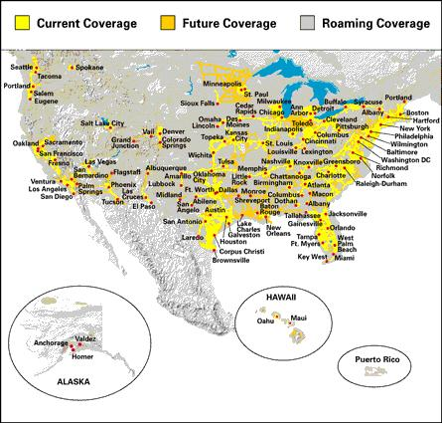
Sprint PCS US Coverage

Verizon Wireless
Coverage Area: California, Colorado, Connecticut, Delaware, Florida, Georgia, Indiana, Kentucky, Maine, Maryland, Massachusetts, New Hampshire, New Jersey, New York, North Carolina, Ohio, Oklahoma, Pennsylvania, Rhode Island, South Carolina, Tennessee, Texas, Vermont, Virginia, Washington DC [Ala.: Mobile; Fla.: Fort Lauderdale, Jacksonville, Miami, Orlando, Tampa; Hawaii: Honolulu, Maui; Ill.: Chicago; La.: New Orleans; Texas: Austin, Dallas/Fort Worth, Houston, San Antonio; Va.: Norfolk, Richmond; Wis.: Milwaukee]
Subsidiaries: Airtouch, Primeco, BellAtlantic, GTE
Protocols Supported: CDPD, CDMA
Devices Supported: Ericsson, Kyocera, Mitsubishi, Motorola, Neopoint, Nokia, Qualcomm, Samsung, Sony, Palm (w/appropriate add-on), Handspring (w/appropriate Springboard module), TRG Pro
Devices Offered: Qualcomm 860, Novatel Wireless Minstrel (PalmPilot) and Minstrel III (Palm III) modems, Novatel Wireless Merlin PCMCIA card modem, Sierra Wireless Aircard 300 for laptops, Nextcell Spider PCMCIA card, Mitsubishi MobileAccess smartphone
Subscription Plans: Web Access Internet Plus Plan: $39.95/month unlimited usage within Verizon wireless network, 8¢/KB roaming (assumes 2 year contract, 1 yr contract costs 54.95/month); Web Access eMail Plus Plan: 24.95/month unlimited messages; Web Access Internet Plus Palm-Only Plan: $24.95/month unlimited usage within Verizon network, 8¢/KB roaming; Palm-Only Traveler Plan: $34.95/month unlimited usage within Verizon network, 6¢/KB roaming
Notes: Palm-only plans can only be used by devices running Palm OS using Novatel CDPD wireless modems. Special business alliances possible for specific vertical market applications. Verizon coverage maps are only available for specific Eastern regions.
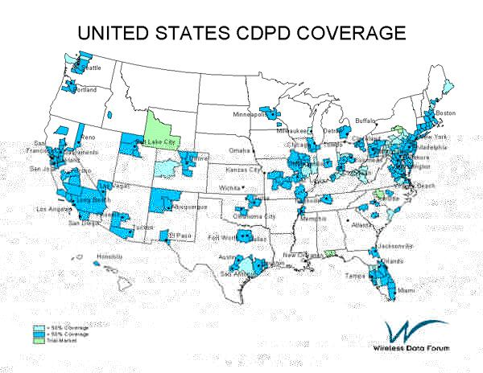
Verizon CDPD US Coverage

VoiceStream Wireless
Coverage Area: Ariz.: Phoenix, Tucson; D.C.: Washington; Colo.: Denver, Fort Collins, Greeley; Conn.: major population areas and connecting highways; D.C.: Washington; Fla.: Miami-Fort Lauderdale-West Palm Beach; Orlando, Tampa; Hawaii: Honolulu; Idaho: Boise; Iowa: Des Moines; Kan.: Wichita; Mass.: Boston; Md.: Baltimore; Mich.: Great Lakes Region including Detroit, Flint, Lansing; Minn.: Duluth, Hibbing, Minneapolis/St. Paul, Virginia; Mo.: Kansas City; N.H.: Manchester; N.J.: Atlantic City; N.M.: Albuquerque, Las Cruces; N.Y.: Albany, New York, Schenectady, Syracuse, Troy; Ohio: Columbus; Okla.: Oklahoma City; Tulsa; Ore.: Portland; Pa.: Lehigh Valley, Philadelphia, Pittsburgh; Scranton/Wilkes-Barre; R.I.: Providence; Texas: Austin, El Paso, Houston; San Antonio; Utah: Salt Lake City; Wash.: Seattle, Spokane, Vancouver; Wis.: Superior.
Subsidiaries: Ariel, Microcel (22.6%), Omnipoint, Powertel (VoiceStream acquisition by Deutsche Telekom pending)
Protocols Supported: GPSR, GSM
Devices Offered: Nokia 6190, 8290, 8890, Motorola G310, G150, Ericsson I888
Devices Supported: Ericsson, Motorola, Nokia, Palm (w/appropriate add-on), Handspring (w/appropriate Springboard module), TRG Pro
Subscription Plans: DataStream optional service at $29.99 includes 1500 data minutes. Otherwise, Internet connection billed as “call minutes” against connection subscription plan. E-notes at $4.99/month includes same number of messages free as minutes free in connection rate plan Regional connection rate plan example (Northeast):

- $19.99/75 minutes/30¢ per minute overage;
- $39.99/600 minutes/25¢ per minute overage;
- $59.99/900 minutes/20¢ per minute overage;
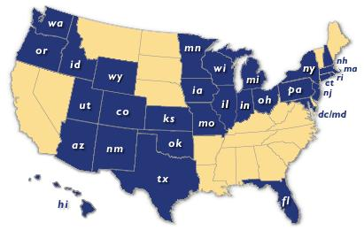

VoiceStream US Coverage

Weblink
Coverage Area: Nationwide
Protocols Supported: ReFLEX
Devices Offered: Motorola Talkabout T900, Pagewriter 2000X, Glenayre AccessLink
Devices Supported: Palm (w/appropriate add-on), Handspring (w/appropriate Springboard module), RIM Blackberry, Motorola Pagers, Glenayre Pagers
Subscription Plans:
- Basic: $9.95/month for first 125 message @ 100 characters each, Additional messages 8¢ per message
- Unwired Lite: $14.95/month for first 250 message @ 100 characters each, Additional messages 6¢ per message
- Unwired Supreme: $19.95/month for first 400 message @ 100 characters each, Additional messages 5¢ per message
- Unwired Extreme: $29.95/month for first 1000 message @ 100 characters each, Additional messages 5¢ per message
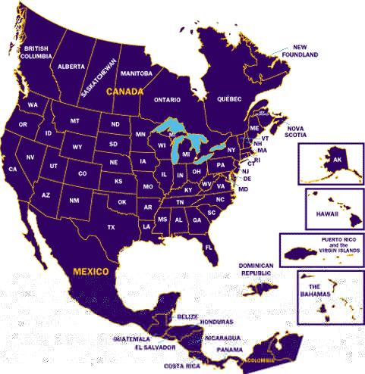

Regional US Wireless Network Service Providers

3 Rivers Wireless
Coverage Area: Mont.: Helena, Great Falls
Protocols Supported: CDMA

Aerial Communications Inc.
Coverage Area:
Affiliate of: Merged with VoiceStream Wireless
Protocols Supported: GSM

Airadigm Communications Inc.
Coverage Area: Wis.: Appleton-Fox Cities, Fond du Lac, Green Bay, Madison, Manitowoc, Oshkosh, Sheboygan
Protocols Supported: GSM
Note: In Chapter 11 reorganization

AirGate PCS
Coverage Area: Ga.: Augusta, Savannah; N.C.: Goldsboro, Greenville, Hickory, Kingston, New Bern, Rocky Mount, Wilson, Outer Banks region; S.C.: Anderson, Charleston, Columbia, Florence, Greenville-Spartanburg, Jacksonville, Orangeville, Roanoke Rapids, Spartanburg, Sumter
Affiliate of: Sprint PCS
Protocols Supported: CDMA

Alltel
Coverage Area: Fla.: Jacksonville
Protocols Supported: CDMA

Amica Wireless Phone Service
Coverage Area: Ill.: Bloomington, Champaign, Decatur, Springfield
Protocols Supported: CDMA

Bell Mobility
Coverage Area: Ontario: Ottawa, Toronto; Quebec: Montreal, Quebec City
Protocols Supported: CDMA

BellSouth Cellular
Coverage Area: Fla.: Tampa Bay
Affiliate of: Subsidiary of BellSouth
Protocols Supported: TDMA

BellSouth Mobility DCS
Coverage Area: Fla.: Northwest Florida; Ga.: Augusta, Savannah; N.C.: Asheville, Burlington, Chapel Hill, Charlotte, Durham, Fayetteville, Hickory, High Point, Gastonia, Greensboro, Raleigh, Wilmington, Winston-Salem; S.C.: Anderson, Charleston, Columbia, Florence, Greenville, Myrtle Beach, Spartanburg; Tenn.: Bristol, Johnson City, Kingsport, Knoxville
Affiliate of: Subsidiary of BellSouth
Protocols Supported: GSM

Blackfoot Communications
Coverage Area: Mont.: Billings; Wash.: Spokane
Protocols Supported: CDMA

Cellular South
Coverage Area: Miss.: Jackson
Protocols Supported: TDMA

Leap Wireless International (Cricket Communications)
Coverage Area: Tenn.: Chattanooga, Nashville
Protocols Supported: CDMA

Cincinnati Bell Wireless
Coverage Area: Ky.: northern; Ohio: Cincinnati, Dayton
Protocols Supported: TDMA

Clearnet
Coverage Area: Alberta: Calgary, Edmonton; British Columbia: Vancouver, Victoria; Nova Scotia: Halifax; Ontario: Ottawa, Toronto; Quebec: Hull, Montreal, Quebec City
Protocols Supported: CDMA

Comtel PCS Mainstreet Limited Partnership
Coverage Area: Unknown
Protocols Supported: GSM

Conestoga Wireless Co.
Coverage Area: Unknown
Protocols Supported: GSM

Cook Inlet Western Wireless PV/SS PCS LP
Coverage Area: Unknown
Affiliate of: VoiceStream Wireless
Protocols Supported: GSM

Cross Telephone Company
Coverage Area: Unknown
Protocols Supported: GSM

DigiPH PCS
Coverage Area: Ala.: Mobile; Miss.: Biloxi, Hattiesburg
Protocols Supported: GSM

Epic Touch Co.
Coverage Area: Unknown
Protocols Supported: GSM

Georgia PCS
Coverage Area: GA: Valdosta
Affiliate of: Sprint PCS
Protocols Supported: CDMA

GTE Wireless
Coverage Area: Ohio: Cincinnati, Dayton; Wash.: Seattle, Spokane
Affiliate of: Merged with Ariel, BAM and PowerTel to form Verizon
Protocols Supported: CDMA

High Plains/Midwest LLC
Coverage Area: Unknown
Protocols Supported: GSM

Horizon Personal Communications Inc.
Coverage Area: Ohio: Chillicothe
Affiliate of: Sprint PCS
Protocols Supported: CDMA

Iowa Wireless
Coverage Area: Iowa: Cedar Rapids, Iowa City
Protocols Supported: GSM

Message Express
Coverage Area: Unknown
Protocols Supported: GSM

Microcell Telecommunications Inc.
Coverage Area: Alberta: Calgary; British Columbia: Vancouver, Victoria; Niagara Region; Ontario: Guelph, Brantford, Cambridge, Kitchener-Waterloo, Ottawa-Hull, Toronto; Quebec: Montreal, Quebec City; Manitoba: Winnipeg
Protocols Supported: GSM

Nevada Bell Mobile Services
Coverage Area: Nev.: Las Vegas
Affiliate of: Subsidiary of SBC Communications
Protocols Supported: GSM

NPI Wireless Inc.
Coverage Area: Mich.: Traverse City
Protocols Supported: GSM

NTCH Inc.
Coverage Area: Colo.: Grand Junction
Protocols Supported: CDMA

NTELOS
Coverage Area: Va.: Charlottesville; W.Va.: Charleston, Huntington
Protocols Supported: CDMA

Omnipoint Communications Inc.
Coverage Area: Folded into VoiceStream
Affiliate of: Acquired by VoiceStream Wireless
Protocols Supported: GSM

Pacific Bell Wireless
Coverage Area: Calif.: Bakersfield, Central Valley, Los Angeles, Modesto, Sacramento, San Diego, San Francisco; Nev.: Tahoe/Reno
Affiliate of: Subsidiary of Qwest
Protocols Supported: GSM

Panhandle Telecommunications System Inc
Coverage Area: Unknown
Protocols Supported: GSM

PCS One Inc.
Coverage Area: Unknown
Protocols Supported: GSM

Personal Comms Network
Coverage Area: Unknown
Protocols Supported: GSM

Pine Belt Wireless
Coverage Area: Ala.: Camden, Marion, Selma
Protocols Supported: CDMA

PinPoint Wireless
Coverage Area: Unknown
Protocols Supported: GSM

Powertel Inc.
Coverage Area: Ala.: Anniston, Auburn, Birmingham, Dothan, Florence, Gadsden, Huntsville, Lanett, Montgomery, Muscle Shoals, Opelika, Tuscaloosa, Valley; Fla.: Gainesville, Jacksonville, Panama City, Tallahassee; Ga.: Athens, Atlanta, Augusta, Columbus, Macon, Savannah, Warner Robins, WestPoint; Ky.: Bowling Green, Frankfort, Louisville, Lexington; Miss.: Jackson, Tupelo; S.C.: Aiken; Tenn.: Chattanooga, Jackson, Memphis; Nashville
Affiliate of: Acquisition by VoiceStream pending
Protocols Supported: GSM

PrimeCo Personal Communications LP
Coverage Area: Unknown
Affiliate of: Subsidiary of Verizon Wireless
Protocols Supported: CDMA

Roseville Communications
Coverage Area: Calif.: Citrus, Folsom, Granite Bay, Orangevale, Rocklin, Roseville
Protocols Supported: CDMA

SBC Ameritech
Coverage Area: Ohio: Cleveland
Affiliate of: Subsidiary of SBC Communications
Protocols Supported: CDMA

SOL Communications
Coverage Area: Texas: south Texas
Protocols Supported: GSM

Southeast Telephone Ltd.
Coverage Area: Ky.: Pikeville; W.Va.: Williamson
Protocols Supported: GSM

South Carolina Phone LLC
Coverage Area: Unknown
Protocols Supported: GSM

TeleCorp PCS
Coverage Area: Ark.: Fort Smith, Little Rock; La.: Houma, Lake Charles, Thibodeaux, New Orleans; Mass.: Auburn, Cape Cod, Martha's Vineyard, Nantucket, Worcester; Miss.: Oxford; Mo.: Columbia/Jefferson City; N.H.: Concord, Manchester, Nashua; Puerto Rico; Tenn.: Jackson; Tx.: Beaumont
Affiliate of: SunCom/AT&T Wireless
Protocols Supported: TDMA

Third Kentucky Cellular Corp.
Coverage Area: Ky.: Corbin, London, Williamsburg
Protocols Supported: GSM

Tritel
Coverage Area: AL.: Anniston, Auburn, Birmingham, Decatur, Huntsville, Mobile, Montgomery, Opelika, Tuscaloosa; GA.: Dalton; KY.: Bowling Green, Corbin, Hopkinsville, Lexington, Louisville, Madisonville, Owensboro; MS.: Biloxi, Brookhaven, Columbus, Gulfport, Hattiesburg, Jackson, Laurel, McComb, Meridian, Pascagoula, Starkville, Tupelo, Vicksburg; TN.: Chattanooga, Clarksville, Cleveland, Cookeville, Knoxville, Nashville
Affiliate of: AT&T Wireless
Protocols Supported: TDMA

Triton PCS Inc.
Coverage Area: Ga.: Athens, Augusta; N.C.: Asheville, Fayetteville, Goldsboro-Kinston, Greenville-Washington, Hickory-Lenoir, Jacksonville, New Bern, Rocky Mount, Wilmington, S.C.: Anderson, Beaufort, Charleston, Columbia, Florence, Greenville-Spartanburg, Greenwood, Hilton Head, Myrtle Beach, Savannah, Sumter; Tenn.: Bristol, Kingsport, Johnson City; Va.: Charlottesville, Danville, Fredericksburg, Harrisonburg, Lynchburg, Martinsville, Norfolk-Virginia Beach, Roanoke, Richmond, Staunton, Waynesboro, Winchester
Affiliate of: AT&T Wireless
Protocols Supported: TDMA

US Unwired
Coverage Area: Ala.: Anniston, Birmingham, Chilton Area Counties, Mobile, Montgomery; Ariz.: Hot Springs, Nevada Area Counties; Ark.: Little Rock, Hot Springs, Nevada Area Counties; Fla.: Jackson Area County, Pensacola; La.: Alexandria, Baton Rouge, Houma, Lafayette, Lake Charles, Monroe, Shreveport, Houma/Thibodaux; Miss.: Jackson, Meridian, Vicksburg; Texas: Beaumont, Longview, Lufkin, Texarkana, Tyler, Nacogdoches
Affiliate of: Sprint PCS
Protocols Supported: CDMA

Wireless Alliance LLC/Unicel PCS
Coverage Area: Minn.: Duluth, Moorhead, Virginia-Hibbing; N.D.: Fargo; Wis.: Superior
Protocols Supported: GSM

WirelessNorth
Coverage Area: Minn.: Moorhead; N.D.: Fargo, Grand Forks
Protocols Supported: CDMA

Wireless Telecoms Co.
Coverage Area: Unknown
Protocols Supported: GSM

References

The information in this report was collected from over thirty different sources including manufacturer web sites, industry web sites, product review web sites, online periodicals and press announcements. These sources included:

Aether
Anywhereyougo
BellSouth
C/Net
CDG.org
CTIA
GoAmerica
GSM MoU
Association
GSM Data
Knowledge
GSMWorld
Mobile Data
Association
Omnisky
Outlook
Palm.net
Palowireless.com
PCS Data
Knowledge
PCSWorld
SBC
Communications
Skytel
Sprint
UWCC.org
Verizon
Wireless Data
Forum
WirelessWeek
YadaYada

